Ruby Mead
Carleton College
300 N College St.
Northfield, MN 55057
meadr@carleton.edu

1751 Words
Light Leaked On Through

On the Friday of our third week in Melbourne, I walked. In the midmorning of balmy city bustle—when the work day had only just begun—I eased the side door of our studio closed and, instead, I just walked. In vintage garb of lime green gingham and taupe Birkenstocks weathered by Tasmanian gravel, I walked up up up the city’s foreign streets and sublime parks and drab expressways until I felt blithely anonymous.
X
During my residency at the Australian Printmaking Studio, Simon and Martin—two graying men with Lennon-reminiscent glasses and wardrobes of exclusively charcoal skinny jeans—armed all thirty of us young, eager-eyed ones with equipment and instruction, handfuls of miscellaneous wisdom, and the occasional trick of the trade. On our first day, Simon whispered that intaglio styles come to life in a ten foot by ten foot ventilated room of endless acid baths, soiled methane rags, rosin chambers, and a single blow torch. As such, a safety mask was required at all times—even if our daubed fingertips would forever stain them black with ink.
The acid room had one wee window up high on the far wall—its petite breadth, frosted and alight with outside sunshine. To the left of the pitiful outlook, students fervidly swung around and around a reinforced square of cardboard duct-taped to a wooden pole—cooling their copper plates in a practiced frenzy. To the right, in the horizontal baths, acid ate away at various sketches of sleepy friends, luscious landscapes, and rats with jobs. In the middle of the room, next to a towering, toxic chamber of aquatint application, Simon stood with a hip cocked and a gas mask handy.
“Right, then. This is where the magic happens.”
X
The craft of intaglio printing required logic. After you incised a masterpiece—or merely a mess-around—onto your copperplate, intermittent exposure to acid bit away at the marks until a layer of ink sank into its many etchings. The longer your plate lies flat in the acid bath, the more likely the ink is to abrase onto paper. In my second print, a gaunt arm lit ablaze a birthday cake topped with loose chamomile and decorative figs; original prose hovered above the simplistic scene. I carved the first layer of marks and soaked the plate for two minutes—I carved finer details and soaked it for three more—I carved hazy shadows and soaked it for five minutes more. I gradually built the darks and the lights with the mind of a mathematician, watching the clock with undue diligence.
Submerge. Watch. Fiddle with cuticles until skin turns crimson. Retrieve. Rinse thoroughly with white vinegar. Dry with spare newsprint. Carve some more. Repeat. My mechanistic body moved back and forth between the main studio and the acid room—my ink-riddled mask yanked up and down, up and again back down.
X
On a particularly inauspicious day, the math of intaglio seemed a touch too confounding. I wanted to engrave varying rays of light upon my testy plate of a birthday cake, I said. This required shielding approximately two thirds of the piece from the grisly bite of the acid, the charcoal-coated men said. A delicate move, unlikely to succeed without tribulations and a tear of happenstance.
“I have an idea!”
Martin sounds British in my memory. His greasy hair parted carelessly in the middle and a dash of moles danced across his upturned nose. Now, he perched against a printing press in nonchalance as I bared my plate for merry inspection. The plastic backing had long peeled away and my right wrist itched yellow in irritation. Martin had a trick, he said. Cover your copper first in sharpie, apply the rosin, fuse the particles down with the blow torch, and soak soak soak until you’re satisfied.
An hour later, I scrubbed my plate with many a methane-drenched rags while tangles of hair congested my vision. The sharpie will work, Martin had said. And so, I scrubbed until my knuckles cramped and a tear slipped on by in dramatics. And, still, the rosin stuck steadfastly to the copper.
What.
The.
Everlasting.
Fuck.
And so, I scrubbed some more under the quickening beat of my windswept pulse. The plate gleamed gold in rebellion and dots of sharpie danced across the cake, the limb, the prose. After two weeks of devout companionship—interned amid the brick walls of our chemically rank studio—my trusty copper now frowned, and I frowned back in reflected deformity.
“Well, I’ve certainly never seen anything like this! You used a name brand sharpie, correct?” Martin’s brow wrinkled like a fat, disgruntled caterpillar.
“Are there any other types of sharpies in this building?” I seethed pleasantly.
“Perhaps you heated the plate for too long? Are you previously familiar with the mechanics of a blow torch?”
My teeth ground till they ached in agitation. “Not particularly, no.”
“I can’t imagine what else it would be! Unless of course you cleaned the plate with turpentine and not methane? They are right next to each other, after all.” His finger now crept up towards his stippled chin – a visage like a chauvinistic detective.
“No, I cleaned it with methane, I’m sure.” My cuticles now bled down down down my mutilated fingertips.
Martin stared back at me in bewilderment. Beside him, Simon chuckled soundly.
“You idiot! Why on earth would you tell her to use a sharpie?”
When, in acquiescence, I printed my engraving, the blots started back at me dull in ink and mangled in expression. And so, I wandered back to my work station with numb, crackling ankles, placed the sickly proof down upon the table, removed my apron seeped in acid splashes, and then, I walked out the door.
X
Early on in the trip, our professor had spoken of the serenity that was Gertrude Street in Melbourne. Indeed, its pastel array of elite shops, innovative brunching, yoga studios, and open-door co-ops with daily sorts of wild flowers had been a most picturesque setting for two whole weeks. Each morning of my stay, I dallied down the three block stretch from my apartment to the studio with a sweet treat in hand and the daily glimpse of a local corgi.
Now, I walked as my father had taught me—with a skip in my step to avoid sexual predators—up the aggravating Gertrude Street. The locals laughed drunkenly at their patio brunch—a bloody mary and a mimosa each in their faltering grip. The dogs looked depleted as they hunched below the benches—jowls panting grotesquely in the sole ounce of shade their fluffy little bodies could find. The cars now honked in vexation and a man in a tweed flat cap nearly lost his thumb to the routine violence of the tram door. My ankles protested in platform sandals as I passed the perfume shop that now induced nausea, the vegan chicken place that had pompously insisted they were “all full” one week prior, and the second hand shop where an early 2000s tank top cost eighty Australian dollars—and no, the conversion rate did not help the matter.
I turned right on Brunswick Street and walked on.
X
I walked along a seeming highway until the incessant honks (not directed towards me, surely?) became particularly troubling. I walked by the ivy-coated dorms of some or another university—where wee baby freshman pushed carts of plastic furniture, microwave ramen, and red solo cups up the teeming queue. I passed by old ladies with parasols and crowds of kids who giggled in ease. I cut through parks where dogs dashed freely, where toddlers in Shortall’s and ribboned pig tails blew bubbles clumsily. I walked past Glenylon Road and Maghull Street, the Melbourne Zoo and a Brilliant Car Wash—a strip of breweries, an array of Louisiana-style mansions, and What The Putt. An artist’s frustration sauntered amid the shadows – I walked past such troublesome echoes with brisk footsteps.
An hour or two in, I whipped out my phone.
“Second hand shops nearby.” Search. Select. Walk.
X
I left Mutual Muse Brunswick with a newfound smile of material contentment and a bag full of clothes that may just overinflate my luggage back home. The pavement fluttered blithely around me. Across the street, a chalkboard read: Used Bookstore Upstairs! I walked up those stairs until the bustle turned into calm.
Stacks upon stacks blanketed me in the smell of withered paper. The carpet was a Burgundy red and crumbs littered its mazelike surface. I skewed my body sideways and tucked the bag o’ retail therapy close to my stomach—slithering past tattered editions of Joyce and Hemmingway and Morrison and Eliot. In the shop’s main room, another graying man in charcoal black looked up and quitequickly back down again.
“Hi!” I croaked in unfounded elation. And hysteria. And a surplus of seven dollar caffeine.
Graying man in charcoal black hmphed without gesture. His gaze stayed stuck to a tablet screen and I giggled in irony. Right back at ya. Hmph. Hmph.
I crept toward a small room just off to the right—and the pitter patter sounds of Simon & Garfunkel echoed around our blistering conversation. Pre-loved pages filled my senses and so I walked. My footsteps rolled leisurely from heel to toe like all my ballet teachers had so fervently instructed—I gazed upon the grandeur of foreign bindings and golden-leafed lettering like a wide-eyed snail. My fingertips swept up international dust as they danced across paper and plastic and leather. I brought my hand up to my nose and sneezed in satisfaction.
A room on the far left held oversized books of photography, landscape, and adventure. I stopped there. The sun shined lazily through a window on the far wall—its rays glittered text after text in kisses. There was no one there and no one cared.
My phone dinged. A message from my mom.
The sunset’s rays are shining through our kitchen window extra pink today! Thinking of you. xx
Attached was a photo of my crooked tree—a dear resident of our city-small backyard. In the background, the Chicago sky was alight with magentas and oranges and silhouettes of scattering robins.
I looked back up at my Brunswick light. It swayed in summer ease as dust drifted up up up and out out out the ajar window without a thought.
X
The next day, I freshly carved and soaked and printed with only the light in my mind.
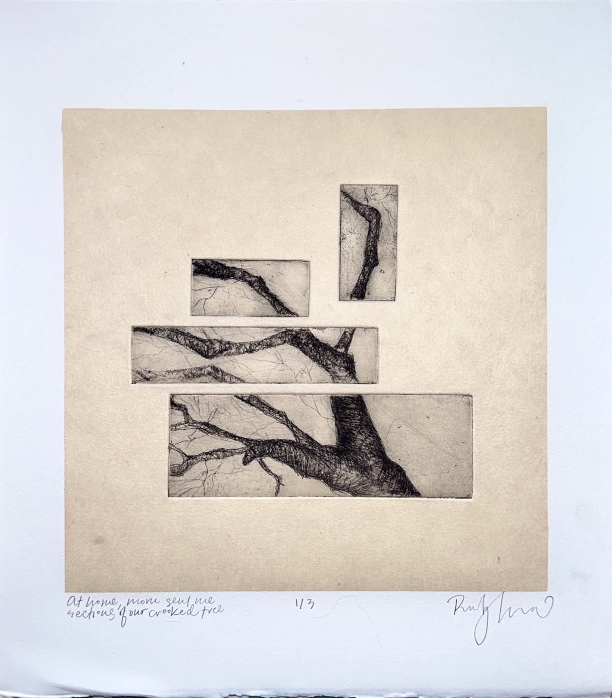

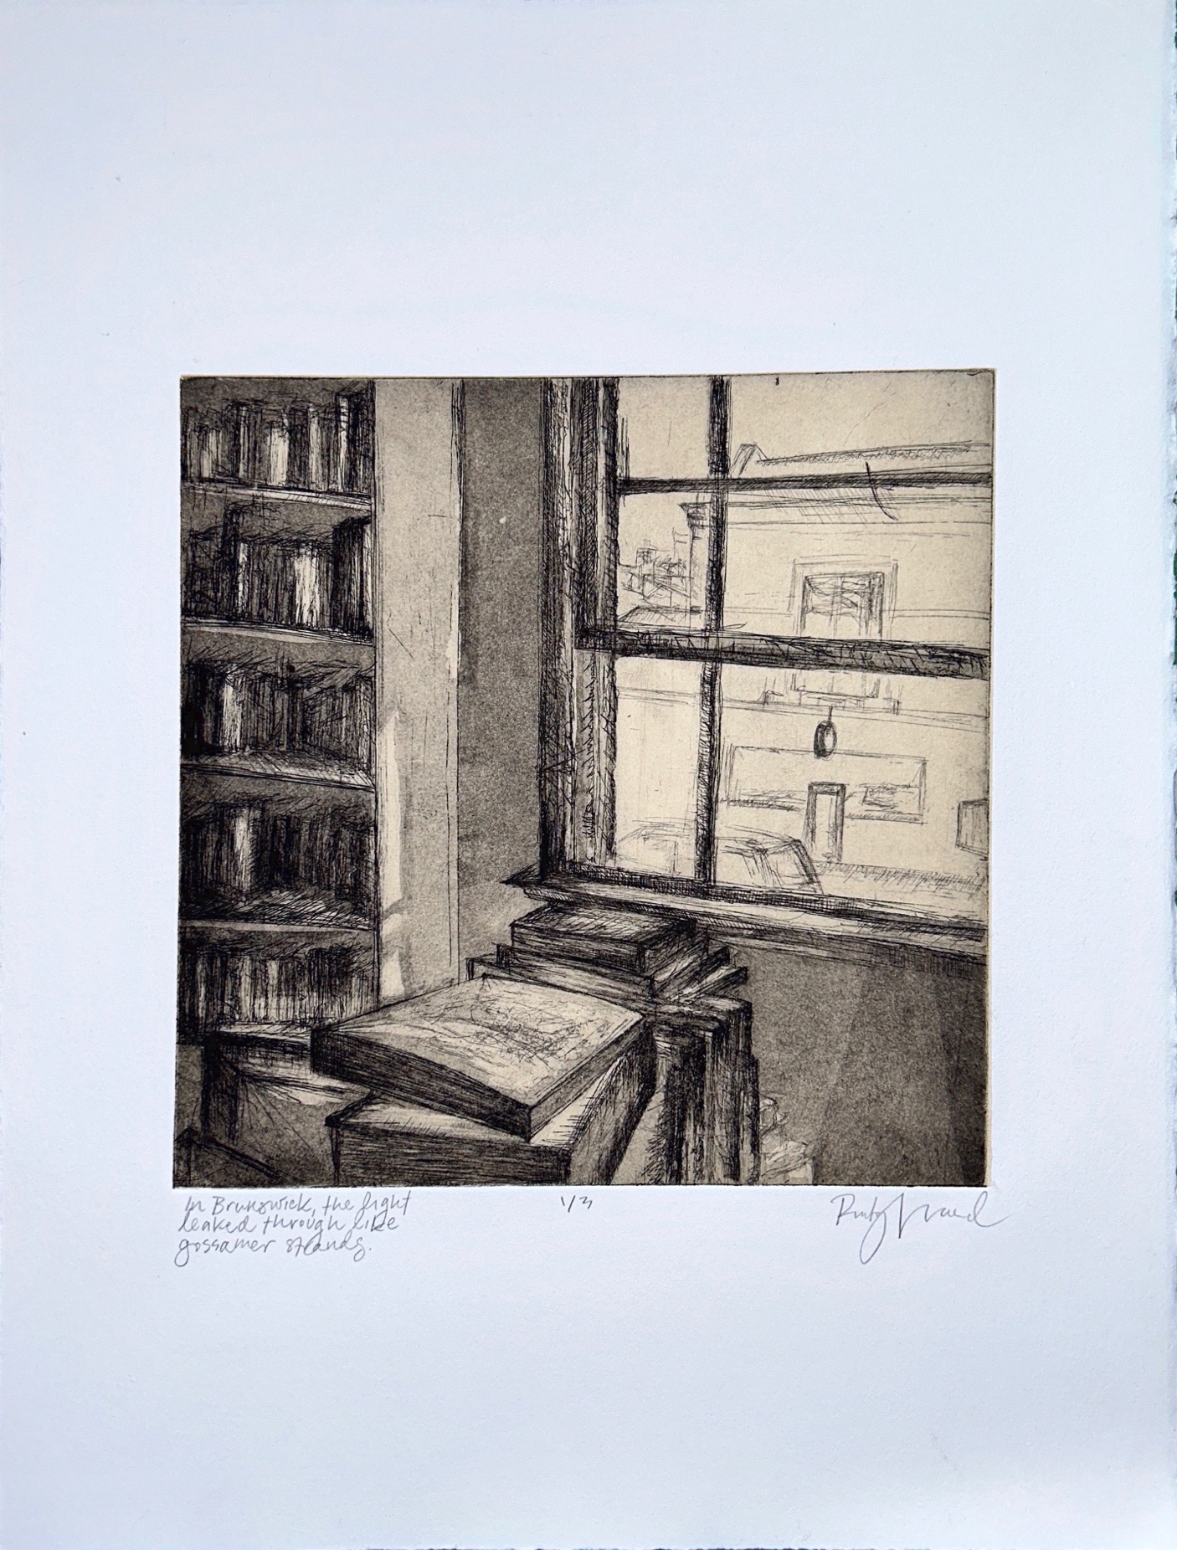

XXX

